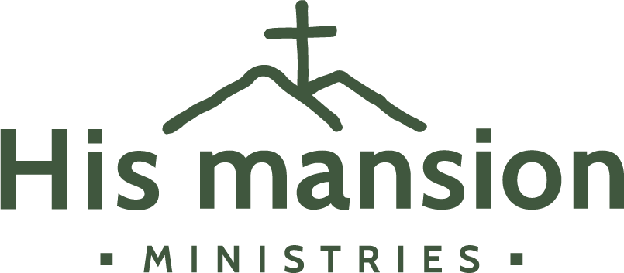

Workgroup Member Application

Dates attending: _____________ Church/School Affiliation: ________________________________

Personal Contact Information
Name: _____________________________________________________ Age: ________ Sex: ________
Name you would like to be called (if different): ___________________________________________
Mailing Address: _____________________________________________________________________
City: _______________________________________ State/Province: _______ Zip: _______________
Country: ____________________________ Primary Phone: _________________________________
Email: ______________________________________________________________________________
Please list any food allergies: ___________________________________________________________
Current Occupation: __________________________________________________________________
Please list other work skills and skill sets (such as hobbies, interests, activities) that you are willing to use during your time at His Mansion. Please also rate your skill level from 1 (some skill) to 4 (could make a living):
____________________________________________________________________________________ __________________________________________________________________________________________________________________________________________________________________________

Do you have any physical limitations that may affect your ability to work?
_______________________________________________________________________________________________________________________________________________________________________________________________________________________________________________________________

*Work Crew
While at HMM you will work with Men’s or Women’s Work Crew, Gardens, Kitchen, or Facilities. Your assignments and projects that will vary depending on the season, weather, and HMM’s needs.

Men’s and Women’s Work Crew usually involves:
- Women: Cleaning, crafts, sewing/mending, decorating, property maintenance, and other tasks as needed
- Men: Throwing and stacking wood, property maintenance, and other tasks as needed

Kitchen usually involves:
- Food prep
- Cooking
- Setting tables
- Dish washing and drying
- Canning/Freezing/Food Processing

Gardens usually involves:
- Preparing the ground
- Planting
- Weeding
- Harvesting

Facilities usually involves:
- Remodeling: such as demo of an old kitchen or bathroom, hanging new drywall, laying tile flooring, painting, etc.
- Repairing: Fixing broken things like doors not closing right, patching holes in walls, repairing windows
- Exterior maintenance: Replacing shingle roofs, painting building exteriors, etc.
- Building projects: building a new wood shed, building a deck, building a picnic pavilion, building a kids playground

Emergency Contact

Name: ___________________________________ Relationship: _______________________________
Phone: ___________________________________ Email: ____________________________________

Background Information
Have you visited His Mansion in the past? If so, when and in what capacity?
______________________________________________________________________________
Would you like a tour of HMM during your visit? ☐ Yes ☐ No
Would you like to receive monthly HMM newsletters? ☐ Yes ☐ No
What led you to desire to serve at His Mansion?
______________________________________________________________________________
______________________________________________________________________________

Media Statement
From time to time His Mansion Ministries may take general or group photographs. By consenting to volunteer here, you consent to appear in our photographs and other media. You will not be identified in photographs. You may decline to appear in, or may step away from, a photograph/media at any time.
If you prefer not to be included in any photographs/media during your stay at HMM, please check the following box: _____ Please do not include me in any photographs/media.
Keep in mind that is it your responsibility to step out of group photos and/or posed photographs/videos/other media.

Please read the following statements and check if in agreement:
_____ I have read and understand the His Mansion Ministries Statement of Faith (see hismansion.com/about/statement-of-faith).
_____ I agree to refrain from asking about a Resident’s past struggles, addictions, trauma, sexual inclinations, or anything overtly personal in nature. I further commit to refrain from counseling or otherwise entering into intense conversations with the Residents.
_____ I agree to be a godly role model during my stay, and to adhere to the structure and requirements of the HMM program as directed both through written material I have received and through any further verbal or written direction given to me before or during my stay by HMM staff or Servant Leaders.

Participant Release of Liability
Assumption of Risk Agreement
*** READ BEFORE SIGNING ***

Organization Name: His Mansion Ministries, Inc.
395 Wolf Hill Road, NH 03244

Participant Name:
Print Name

In consideration of being allowed to participate in any way in the program, related events and activities, and use of equipment, I, the undersigned, acknowledge, appreciate, and agree that:
- There is a risk of injury from the activities involved in this program.
- I knowingly and freely assume all such risks, both known and unknown, even if arising from the negligence of the releases or others, and assume full responsibility for my participation.
- I willingly agree to comply with terms and conditions for participation. If I observe any unusual significant hazard during my presence or participation, I will remove myself from participation and bring such to the attention of the nearest staff immediately.
- I, for myself and on behalf of my heirs, assigns, personal representatives and next of kin, hereby release, indemnify, and hold harmless His Mansion Ministries, its officers, officials, agents and/or employees, other participants, sponsors, and, if applicable, owners and lessors of premises used to conduct the event, from any and all claims, demands, losses, and liability arising out of or related to any injury, disability or death I may suffer, or loss or damage to person or property, whether arising from the negligence of the releases’ or otherwise, to the fullest extent permitted by law.

Health Statement
I will notify His Mansion Ministries Inc. employees if I suffer from any medical or health condition that may cause injury to myself, others, or may require emergency care during my participation.

I have read this release of liability and assumption of risk agreement, fully understand its terms, understand that I have given up substantial rights by signing it, and sign it freely and voluntarily without any inducement.

X _______________________________________________________ Date __________
Applicant’s Signature
For Parents/Guardians of Participant of Minor Age
(Under age 18 at time of registration)

This is to certify that I, as parent/guardian with legal responsibility for this participant, do consent and agree to his/her release as provided above of all the releases’, and for myself, my heirs, assigns, and next of kin, I release and agree to indemnify and hold harmless the releases’ from any and all liability incidents to my minor child’s involvement or participation in these programs as provided above, even if arising from the negligence of the releases’, to the fullest extent permitted by law.

X _______________________________________________________ Date __________
Parent’s/Guardian’s Signature

